Repository Pattern
Tuesday, April 14, 2020
9:55 AM

Repository Pattern
https://www.youtube.com/watch?v=rtXpYpZdOzM&list=PLQ6l4-2ad0uiSV1v42LyvYnsmSKiRPKS4&index=16&t=1234s
Benefits:
Minimizes duplicate Query Logic
Decouples your application from persistence frameworks - like ADO.Net; LINQ to SQL; Entity Framework V1, EF V4, EF V7 , Dapper, ORMLite…
Promotes testability

Repository Architect:

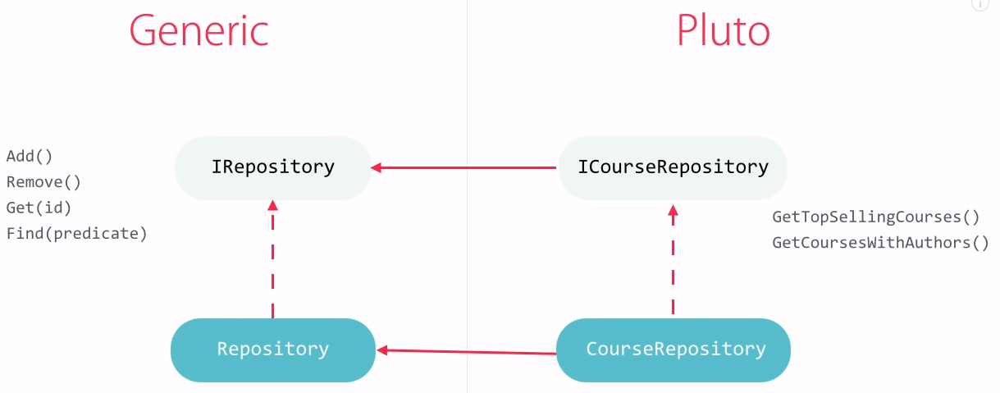

Irepository:
Puublic interface Irepository<Tentity> where Tentity:class
{
Tentity Get(int id); Ienumerable<Tentity> GetAll(); Ienumerable<Tentity> Find(Expression<Func<Tentity,bool>> predicate); void Add(Tentity entity);…..
}
Public class Repository<Tentity>:Irepository<Tentity> where Tentity:class
{
Protected readonly DbContext Context;// Would be initialized in ctor as injection
Public Tentity Get(int id){ Context.Set<Tentity>().Find(id);}
//Implementation…
}
Public interface ICourseRepository:Irepository<Course>
{
Ienumerable<Course> GetTopSellingCourses(int count); Ienumerable<Course> GetCourseWithAuthors<int pageIndex, int pageSize);
}
Public class CourseRepository:Repository<Course>, ICpurseRepository
{ //Implementaion of the functions that defined in ICourseRepository
Public PlutoContext PlutoContext
{ get=>Context as PlutoContext;
}

Public interface IunitOfWork:Idisposible
{
ICourseRepository Courses{get;}
IAuthorsRepository Authors{get;}
Int Complete();
}
Public class UnitOfWork:IUnitOfWork
{
Private readonly PlutoContext _context;
Public UnitOfWork(PlutoContext context){_context = context; Courses = new CourseRepository(_context); Authors = new AuthorRepository(_context);}
Public ICourseRepository Courses{get; private set;}
Public IAuthorRepository Authors{get; private set;}
Public int Complete{return _context.SaveChanges();}
Public Dispose(){_context.Dispose();}
}

